SIES COLLEGE OF ARTS, SCIENCE AND COMMERCE (AUTONOMOUS),
SION WEST, MUMBAI - 400 022

SEMINAR REPORT

Title of the Seminar: Epidemics to Pandemic: Challenges Met and Lessons Learnt

Theme: Historical and contemporary perspectives on public health policies and management

Objectives:
- To understand past experiences and learnings from the epidemics and pandemics with reference to the Bombay Presidency
- To understand the learnings and experiences from India, particularly states of Maharashtra and Madhya Pradesh during the Covid-19 outbreak
- To understand the social, economic, cultural, political, and environmental impact of the pandemic
- To deliberate upon the pandemic and implications on technological and governance aspects of society

Date and Time: 18th and 19th November 2021 (Online- MS TEAMS)

Attended Participants number: 129

Details of Webinar: The Departments of Politics and History organized a two-day National Webinar on “Epidemics to Pandemic: Challenges Met and Lessons Learnt” in collaboration with Dr. B.R. Ambedkar University of Social Sciences, Mhow, Madhya Pradesh as an initiative to understand the unprecedented health crises in the past and the present. The key themes of this webinar sought to unravel the experiences and responses of two important states of India, namely, Maharashtra and Madhya Pradesh. The resource persons came from diverse fields of expertise which included both academics and professionals in fields of public health. This diverse panel shared their insights and remarks on the topic.
Name of Resource Persons:
- Dr. Mridula Ramanna, Medical Historian and Former Head, Department of History SIES College, Mumbai
- Prof. D.K. Verma, Professor, Dr. B. R. Ambedkar University, Mhow, M.P
- Dr. Sumedh M K, Public Health Consultant to the Government of Maharashtra
Outcome:
- Deliberations on social, economic, political aspects of the pandemic related crises.
- Governance issues and responses of public health departments were critically analysed

Annexures:
- Photographs:
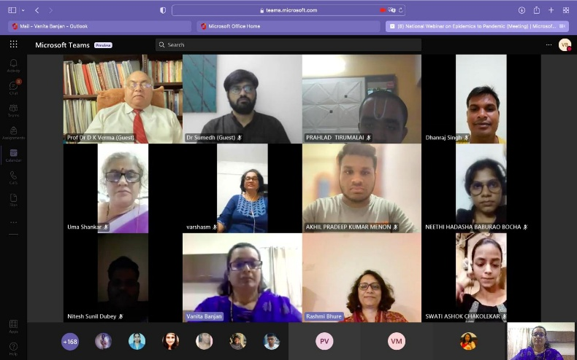

iii. List of Participants:
Sr No. | Name of Participants
1 | Vanita Banjan
2 | Varsha Muley
3 | Rashmi Bhure
4 | Akhil Pradeep Kumar Menon
5 | Niharika Nandakumar Jyoti
6 | Vedang Mukund Deshpande
7 | Poojary Grisha Shridhar Kavita
8 | Nagar Saumya Vivek Pragya
9 | Neha Paresh Pawar
10 | Devika Sudalaimuthu Yadav
11 | Prof. Dr D K Verma (Guest)
12 | Prabhat Deepak Iyer
13 | Saba Nazim Solkar
14 | Monchiraju Anagha Prasannakumar Shital
15 | Pavitra Kishore Kunder
16 | Kashish Jatin Nandrajog
17 | Dr Sumedh (Guest)
18 | Chandat Saraswati Ranchod Ganga
19 | Pranav Sriram
20 | Samreen Gavin Dias
21 | More Himanshu Nilesh Kumar Leena
22 | Suganya Sivaraja
23 | Pinto Marilyn Mario Marie Lourdes
24 | Kavitha Acharya
25 | Naidu Amrutha Lakshminarayanan Ramamaya
26 | Thakker Khushi Vishal Mili
27 | Mendonca Jessica Jerome Theresa
28 | Mahalaxmi Samuthiram Nadar
29 | Nandhini Murugan Yadav
30 | Kalyani Jagdish Gautam
31 | Yatnalkar Shruti Bhaskar Gitanjali
32 | Kalpana Venkateswarao Digamarty
33 | Siddhi krishna Parab
34 | Sangeeta Murugesan Konar
35 | Sania Feizal Poonawalla
36 | Seniga Subramaniyam Naidu
37 | Merin Elizabeth Mathew
38 | Priya Narayan Shetty
39 | Pawar Siddhant Nagesh Meena
40 | Riddhi Punit Shah
41 | Masanam Maheshgurunathan Konar
42 | Swati Ashok Chakolekar
43 | Sherrylann Ossie Dmello
44 | Shetty Divya Divakar Anita
45 | Trisha Sadanand Moily
46 | Marthuwar Abarna Thakshnamurthy
47 | Vigi Selvasunder Nadar
48 | Chaitali Tushar Dandekar
49 | Shivani Ravichandran
50 | Kareena Jayanth Pai
51 | Sumaiya Aadil Shaikh
52 | Patil Prisha Chetan Urmila
53 | Mrunal Maruti Pawar
54 | Aakanksha Madhukar Wakade
55 | Prahlad Tirumalai
56 | Joshi Mrunmayi kishor Hema
57 | Balakrishnaveni Paramaswaran Nadar
58 | Jaiswal Ankush Janardan Prasad Pushpa
59 | Balakrisnan Aakansha
60 | Pranika Jogesh Bindra
61 | Kazi Mallikah Mushtaq Sayeeda
62 | Pritika Pankaj Kantak
63 | Ratna Subhash Chandra kori
64 | Shruti Dharmendar Sharma
65 | Nandhini Jayasankar Jayasankar
66 | Priya Rakesh Davangere
67 | Bhuvanagiri Sumeet Sadashiv Jyothi
68 | Ruke Sara Santosh Shweta
69 | Samrah Aqeel Qureshi
70 | Palakshi Chetan Sathe
71 | Divya Mary
72 | Caleb Bastin Abby
73 | Bonny Michael Ukken
74 | Maru Minaxi Bipin Deepa
75 | Dhanashree Ravi Iyer
76 | Angel Anand Asade
77 | Kamala Srinivas
78 | Khadija Yusuf Khan
79 | Sakore Arya Jalindar Kanchan
80 | Tanuj Swaminathan Iyer
81 | Shabnam Abdul Rehman Shaikh
82 | Abi Mariya Nirmala MurugaN Nadar
83 | Jidnyasa Rajesh Kulkarni
84 | Rutuja Ravindra Dharmadhikari
85 | Jeslin Joseph Celin
86 | Nitesh Sunil Dubey
87 | Akshathaa Seshan Agila
88 | Ananya Ganesh Iyer
89 | Ansari Husnara Mohd Jameel Akhtar
90 | Drashti Mohan Maru
91 | Shifa Sayed Fakir Md Khan
92 | Rehmat Hanif Kazi
93 | Nandita Murali Vasudevan
94 | Dwivedi Shivam Santoshkumar Bharati
95 | Anushiya mahamani dravid
96 | Firdos Fatma Dilshad Husain Sayyed
97 | Abirami Sri Kumar Pallavarayar
98 | Riddhi Naresh Mehta
99 | Bhalerao Vanshika Vivek Saroj
100 | Trisha Sachin Mohite
101 | Vivek Shivaram Iyer
102 | Nandita Ravindra Kamath
103 | Chris Manuel Chettiar
104 | Ballal Riya Rajesh Geeta
105 | Arshiya Banu Mohd Yusuf Tamboli
106 | Jolin Anson Fernando
107 | Sakshi Ashish Vora
108 | Kathryl Tanusha Gnanasekar
109 | Prof Dr D K Verma (Guest)
110 | Brijesh Shree Rajesh kumar Pasi
111 | Karthika Sunderesan
112 | Ayushh Kishore Iyer
113 | Kothari Vanshika kamlesh Sunita
114 | Vedansh Natarajan Iyer
115 | Josna Brigit Sijin Mettilda Sijin
116 | Sreenidhi k v Jayasree
117 | Sara Mukesh Shah
118 | Jancy Rani Muthu Nadar
119 | Idrisi Shama Ashraf Gulam Abdul Qadir
120 | Priyanka Ramji Mishra
121 | Krithika Parasuraman Parasuraman
122 | Farhana Fathe Bahadur khan
123 | Raksha Vishal Mishra
124 | Arunadevi Samuthirapandi Nadar
125 | kirti Suresh kumar Verma
126 | Uma Shankar
127 | Theresa Kattukaren
128 | Neha Dubey
129 | Ajinkya Gaikwad

Report Prepared by
Signature :-
Name : Dr. Rashmi Bhure
Department: Politics
Designation : Head of the Department
Signature of Principal:

